**‘Managing Big Feelings’**

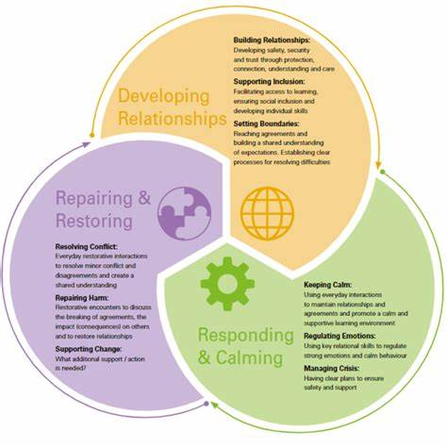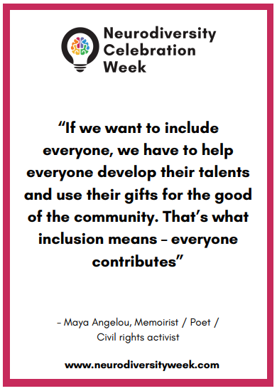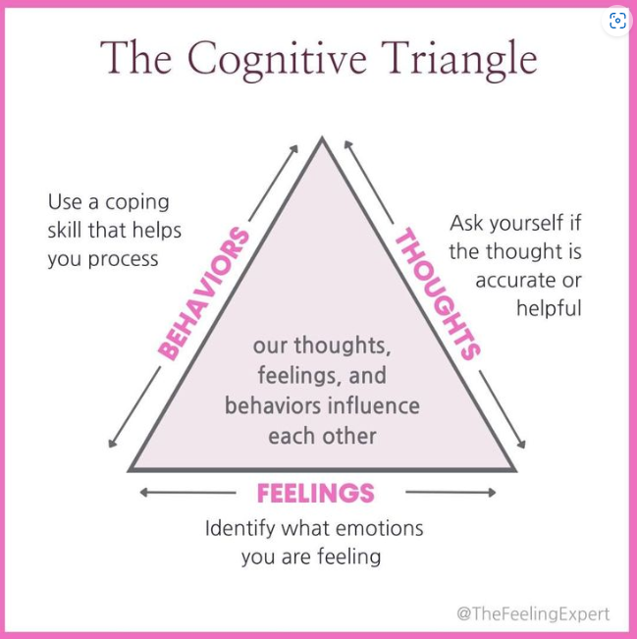

**Interactive online presentations offering relevant approaches and practical tools to help you support your children with their Big Feelings!**

*10am-12pm Thursdays, starting on the 13th of March.*

**What kind of things will the presentation cover?**

* *Each week we will look at a different Big Feeling including Anxiety/Worry, Anger, Sadness and finding our Calm.*
* *We will share up-to-date research about what is happening in a child’s body and brain when they are dealing with Big Feelings*
* *We will learn about the building blocks of confidence and resilience: helping children feel Safe, Seen, Loved and Understood*
* *We will gain understanding around how attachment and trauma can impact a child and how we can best support them*
* *We will look at practical tools, scripts and ways of responding that you can use to support your child, deal with difficulties and repair conflict*

**When, where, how?**

* *The workshop will last for 2 hours, 10am-12pm, Thursdays starting on the 13th of March, ending 3rd April. We ask you to attend for the full duration of the presentation.*
* ***Please click on this link to attend each online workshop (held weekly, same time)***
* [**Join the meeting now**](https://teams.microsoft.com/l/meetup-join/19%3ameeting_MTYzMTBhMzktNjBjNS00MjZmLWI4NTAtNWRlZGQxNzU5NGFk%40thread.v2/0?context=%7b%22Tid%22%3a%22e3150dc9-9ef4-4573-9144-678c2b1da4fd%22%2c%22Oid%22%3a%2287e80a25-523c-4202-9da2-6a78c8c7554e%22%7d)

Meeting ID: 370 593 451 461

Passcode: Bb9Jj6Vv

*These sessions are provided by the Inclusion Hub and will be facilitated by Sibi Moore. Sibi has worked with the Hub for many years offering courses for both children and adults. She is also a counsellor and facilitator.*